DAY 7

CLASS EXERCISE 1

 @PostMapping("/api/person")

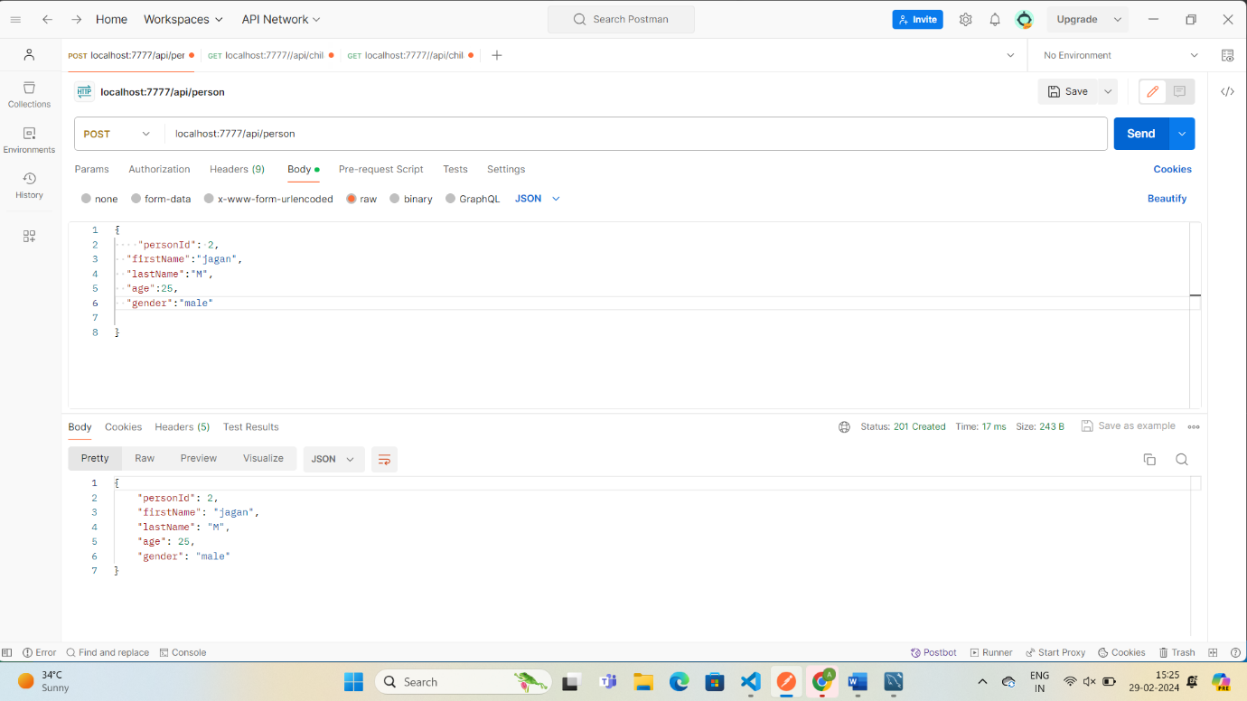

 @PostMapping("/api/person")

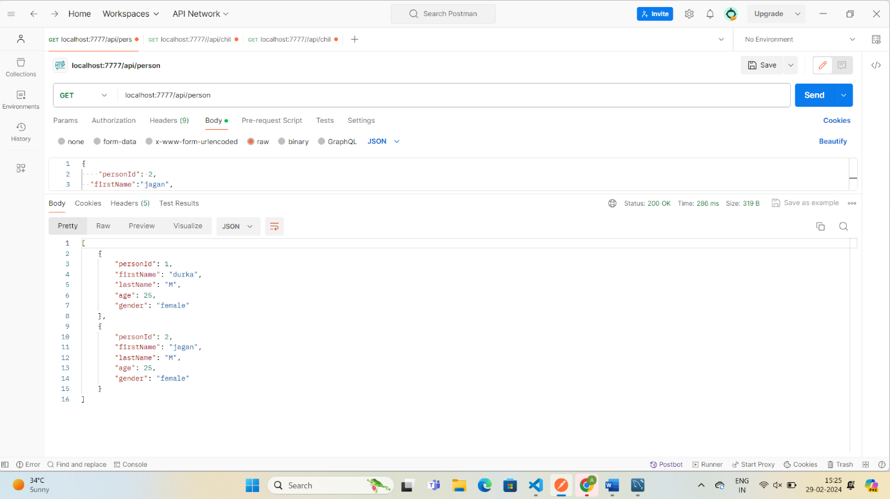

 @PostMapping("/api/person/byAge/{age}")

